652414043

Agreement url:   
  
  
  
http://qdhys.ijournal.cn/hyyhze/ch/index.aspx

Current Issue

Page Range

English Title

Publication year, volume, issue

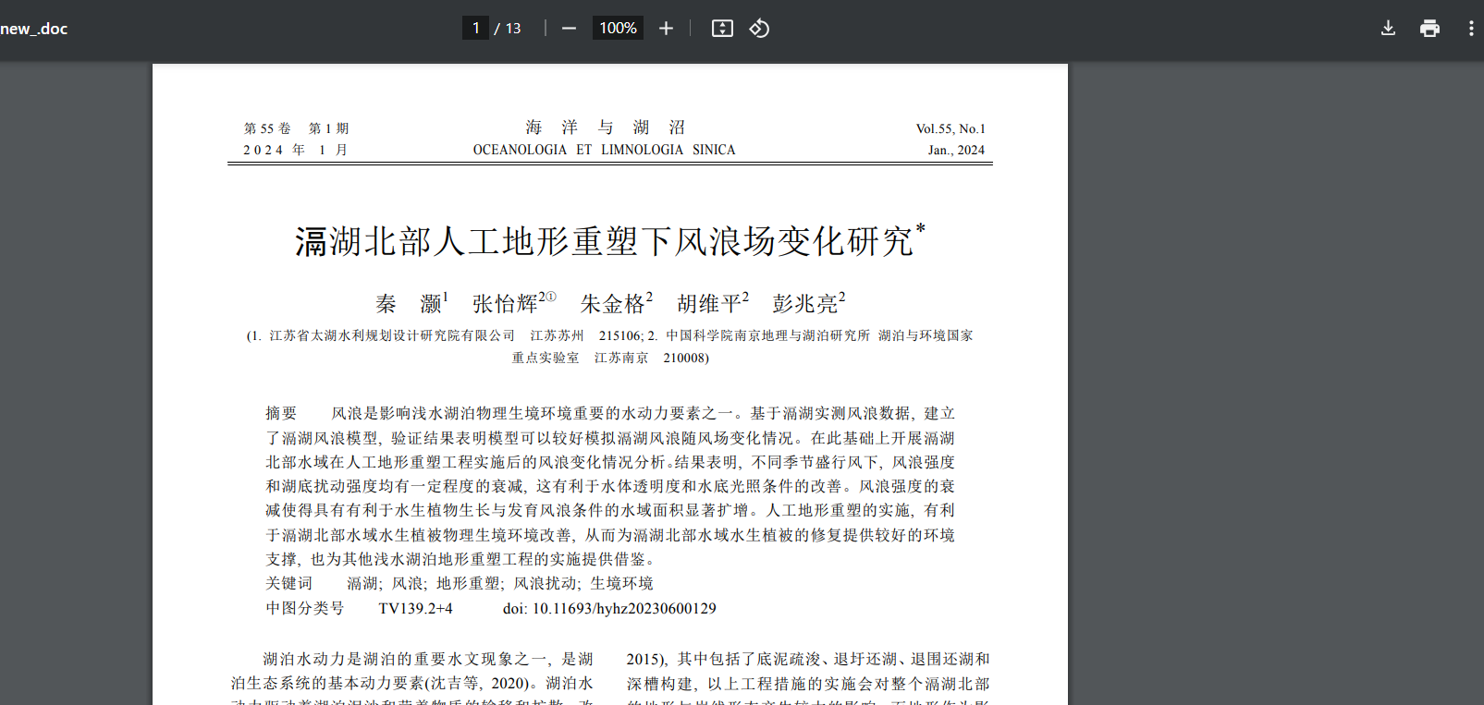

Month

Download PDF

DOI

* **In here both English and Chinese toc needs to be captured so choose language option from website language conversion . then go to the Table of content page right click and save as pdf and merge in to one.**